Print these, cut them out, and glue them into your math notebook on the first clean page!

Converting improper fractions to mixed numbers:
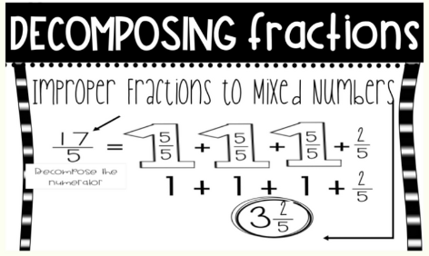

Converting mixed numbers to improper fractions:
