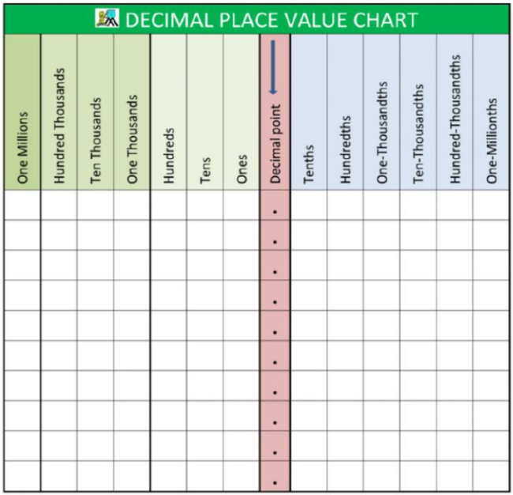

Please print, cut, and glue this in your math notebook on the first clean page!

