Please print, cut, and glue these down in your math notebook on the first clean page!
Classifying Triangles:
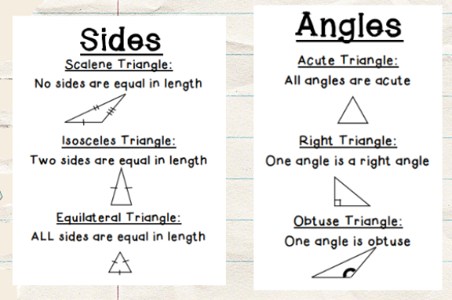
Finding the Area and Perimeter of Polygons:
