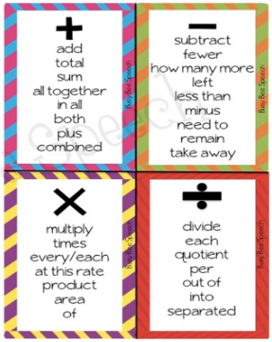
Please print, cut, and glue down into your math notebook on the first clean page.

