Name:
Date:

Energy Resources

Solar Cooker
Did you know that heat from the sun could cook hot dogs just like a campfire? Build a solar cooker of your own and watch how the temperature rises.
Note: For best results, test the solar cooker on a sunny day in the early to mid afternoon.

Materials needed:
Shoebox
Thermometer
String
Poster board
Aluminum foil

Part 1: Build a Solar Cooker
- Line the inside of a shoebox lid with some aluminum foil.
- Place a thermometer in the lid and place it in the sunlight. Write the temperature down in your science journal.
Figure 1: Solar cooker
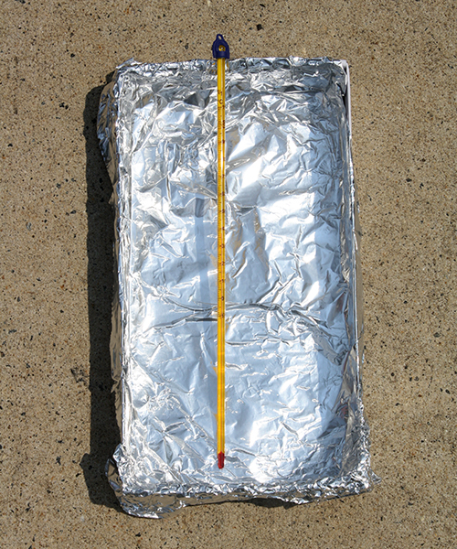
- Wait 10 minutes, and then record the temperature again. Move the lid into the shade and make the next part of the solar cooker.
- Cut a piece of poster board into a rectangle 10 cm by 30 cm. Cover it with aluminum foil. Take care to make the aluminum foil as smooth as possible over the cardboard.
- Use scissors to poke a hole about two cm from each end of the rectangle. Tie one end of a piece of string through one of the holes.
- Pull the piece of string until the ends of the rectangle are 20 cm apart. This should make the rectangle bend, or bow. This will be the reflector piece of the solar cooker. Tie a knot in the other hole to secure the string.
Figure 2: Solar cooker reflector
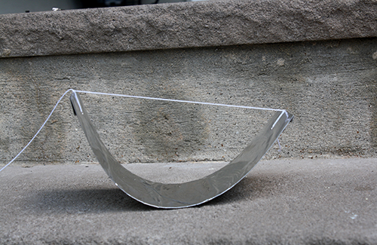
- Move the cooker back into the sunlight. Put the reflector in the shoebox lid with the thermometer between the two ends of the reflector. Note: The bulb of the thermometer should be about 4 centimeters above the bottom of the reflector. One way to do this is to rest the thermometer on the lip of the shoebox lid and the string of the reflector. The thermometer should not be resting on the bottom of the reflector.
Figure 3: Solar cooker with reflector
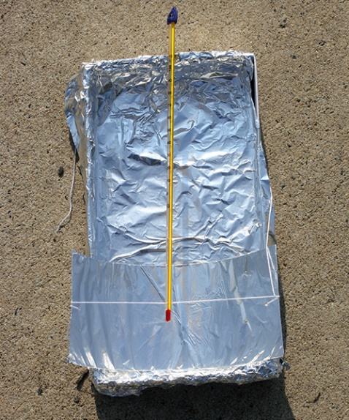
- Record the temperature. Leave the solar cooker in the sun for another 10 minutes, and then record the temperature again.

Questions:
- When did the temperature inside the shoebox lid go up the most, before or after the reflector was added?
______________________________________________________________
- What is the purpose of the reflector in the solar cooker design?
__________________________________________________________________________________________________________________________________________________________________________________________

Part 2: Design it!
Your task is to revise the original procedure and make a design improvement to see if you can increase the ability of your solar cooker to collect and hold heat. Use what you learned about insulators in this unit and any materials you have around the house. Test your design revision by recording the temperature in the lid and then setting out your design in the sun for 10 minutes and recoding the temperature again. Compare to the original result. Record your design changes in the space below and your result.
Changes I made to solar cooker design:
____________________________________________________________________________________________________________________________
____________________________________________________________________________________________________________________________
____________________________________________________________________________________________________________________________
Was your design change successful in collecting/holding more heat? If it was not successful, explain why you think it did not work or what you would di differently if you could try again.
____________________________________________________________________________________________________________________________
____________________________________________________________________________________________________________________________

